College of Education
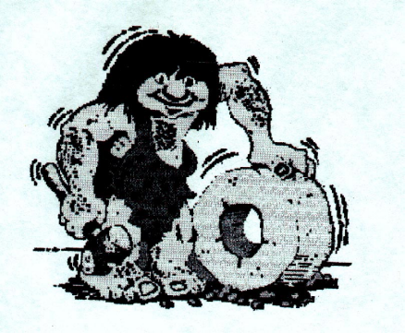Technology is age old and forever.
School of Sciences and Physical Education
Technology Education
Name:__________________________
Date:___________________________

Technological Practice Case Study Comparison

Elements of Comparison | Case Study One  Unique features | Similarities or Common features | Case Study Two  Unique features
Name of Practice and Technologist
Technological Outcome (Product or System)

Motivation for the Technological Outcome

Interaction with clients and or stakeholders
Planning for Technological Outcome development

Challenges for undertaking Technological Practice to develop the Technological Outcome
Other

